|  |
| --- |
| **Quiz-Time**  ***A full-stack project Report submitted partial fulfilment of the requirements for the***  ***Award of the degree of***  **Bachelor of Technology**  **In**  **Computer science and Engineering**  **By**  **Sparsh Gupta (181500723)**  Under the Guidance of  **Mr Pankaj Kapoor**  Department of Computer Engineering & Applications  **Institute of Engineering & Technology**    **download (3)**  **GLA University**  **Mathura-281406, INDIA**  **2020** |



**Department of Computer Engineering and Applications**

**GLA University, 17 km. Stone NH#2, Mathura-Delhi Road, Chaumuha, Mathura – 281406 U.P (India)**

**Declaration**

I/we hereby declare that the work which is being presented in the full-stack project **“Quiz-Time”**, in partial fulfilment of the requirements for the award ofthe ***Bachelor of Technology*** in Computer Science and Engineering and submitted to the Department of Computer Engineering and Applications of GLA University, Mathura, is an authentic record of my/our own work carried under the supervision of **Mr. Pankaj Kapoor** who is **Assistant Professor** in GLA University.

The contents of this project report, in full or in parts, have not been submitted to any other Institute or University for the award of any degree.

Sign __Sparsh ___________

Name of Candidate: Sparsh Gupta

University Roll No.: 18150723

**Acknowledgement**

It is my pleasure to acknowledge the assistance of **Mr. Pankaj Kapoor** without his guidance this project would not have been possible. First and foremost, I would like to express our gratitude to Mr. **Pankaj Kapoor,** my project guide, for providing invaluable encouragement, guidance and assistance. After doing this project I can confidently say that this experience has not only enriched me with technical knowledge but also has unparsed the maturity of thought and vision.

The attributes required being a successful professional.

Sign __Sparsh ___________

Name of Candidate: Sparsh Gupta

University Roll No.: 18150723

**Abstract**

**Quiz-Time** is a web-based examination system where quiz is taken online i.e. through the internet using computer system. Quiz-Time offers new aspects of learning and improving knowledge in educational area.

The purpose of Quiz-Time is to take Exams in the form of quizzes in an efficient manner and no time wasting for checking the paper. Quiz-Time will efficiently evaluate the candidate through a fully automated system that not only saves lot of time but also gives fast results. The system carries out the examination and auto-grading for multiple choice questions which is fed into the system. It manages all the information about Students, Results, Papers. Teachers can administer quizzes using it. The system will show one’s score after the examination is finished. A teacher has control in the question bank and is supposed to make schedule for the quiz. Administrative control of the whole system is provided.

The purpose of the project is to build an application program to reduce the manual work for Marks, Courses, Papers. The project is totally built at administrative end and thus only the administrator is guaranteed the access.

**Contents**

**1. INTRODUCTION…………………………………**

1.1 Motivation

1.2 Objective

**2. REQUIREMENTS SPECIFICATION………..**

2.1 Hardware requirements

2.2 Software requirements

**3. TECHNOLOGIES USED…………………………..**

3.1 HTML

3.2 CSS

3.3 Javascript

3.4 Bootstrap

**4. Project designs…………………………………..**

**5. Use case diagram………………………………..**

**6. Limitation………………………………………….**

**7. Future Scope………………………………………….**

**8. Advantages………………………………………….**

**9. Conclusion………………………………………….**

**10. References………………………………………….**

1. **Introduction**

In the early days manual system was the most popular method in assessing students. Still now the system is quite popular to the students as well as to the teachers. In this system there are several problems that we have faces in common way. First of all Manual checking require pen paper and pencil. Teachers need to spend time in the script checking. Students also have to wait to get their result up to the teacher finishes the script checking. For these causes maual system decreases day by day and onine quiz system taking place of manual quiz system. Now a days, web based quiz system is getting popular with tremendous speed. As a step of development we have also created a fully automated web – based quiz system.Development of this website named “Quiz-Time” is mainly required by students and learners to prepare themselves for different examinations directly through smart phones and tablets in hands. One of the major goal of our project is to facilitate students in learning, gaining and improving their knowledge skills. At the meantime, Quiz-Time provides them fun so that the users can attempt entrance tests or any other corresponding purposes in a fresh mood and can’t get bored or frustrated. We designed this website to facilitate the users to be able to take short quizzes using portable devices such as smart phones and tablets.

There are many online quiz applications available on internet, but most of them are only for entertainment and fun. Moreover, if one is going to appear in any test or interview, then it is difficult and time consuming for them to read the full books or articles related to specific fields for the preparation or revising their knowledge. But the most attractive feature of our project is that we take learning and fun side by side. Our website provides them the facility to revise their knowledge or to learn something advantageous at one place without wasting their time.

Our project will help to overcome the problems occur in manual system with the help of new technologies we are having these days. With the help of this online quiz system we can also stored the valuable information and data over a long period of time. This online quiz website is for to take the online test in an efficient manner and no time wasting of time in checking the paper, conducting the exam in various centers and places from which many students have problem to reach the destination before the exam time.

It can also lead the error free, secure and reliable management system. From this particular organization also keep the information without redundancy. It is user-friendly and fully automated system where one can easily perform the test organized by an organization. Users have to just click the right option which he thinks to be correct and the next question will automatically appears on his screen after the several seconds which is set by instructor. It can be used anywhere and anytime. One can also view the results at the same time after submission of test.

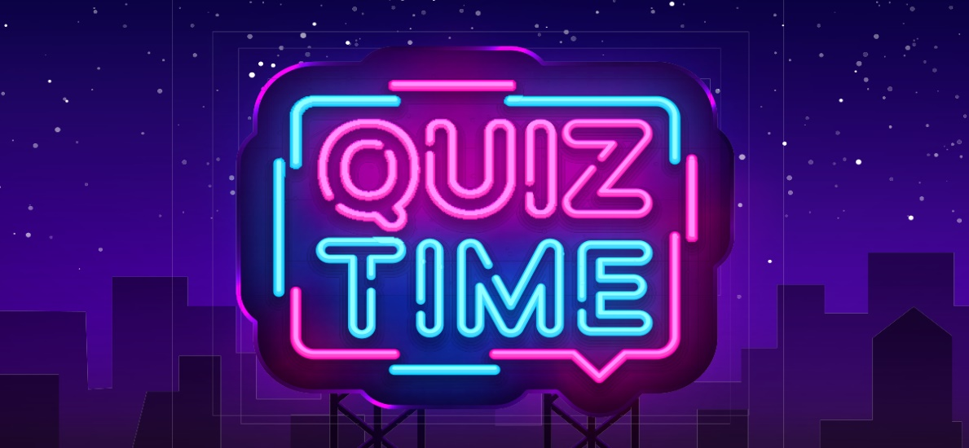

To design and implement this project we plan that the project support to different types of users apart from its administrative part. When project is run for the first time it allowed the user to select as who he/she wants to login in the system. Project support login as teacher and login as student. If a user who is student, try to login as teacher system will not allow him and vice versa. User who add as teacher in system will be able to conduct test and questions to system and also will be able to observe the result of the student which attempt tests. User who login to system as student will be able to select a particular test and attempt questions depend on this test. After attempting the test and submitting that user will receive a message that you have attempt the test successfully and if the user tries to attempt the same test, system will not allow him/her. Also a user which login to system as student will be able to observe the result of test he/she attempt.

**1.1 Motivation :**

Currently most of the examination like organisational recuritment, university class test, school test e.t.c are paper based which costs time and resources. Questionnaire is developed, printed and then collect data entry, editing, cleaning which is time consuming and costly. Proposed project is the starting for avoid those circumstances which are been faced by any organization.

**1.2 Objective :**

Project Objectives

The main objective of the project is to manage the details of students,

examinations, marks, courses and papers. The project is totally at administrative end and thus only the administrator is granted the access. This project manages the details of students and their marks. The main purpose of this project is to eliminate the manual work of managing the no. of students, their details and details of examination, results and marks. It will track all the details and store the details so that we can access it anytime.

The purpose of the project is to build an website to reduce the manual work for managing the MCQ quiz and we will follow to achieve these objectives in this project.

- To create an appropriate platform for best managing of MCQ test;

- To overcome the time consuming issues and taking MCQ tests;

- To release the marks of the test taker as soon as possible;

- To manage the information of different tests.

**REQUIREMENTS SPECIFICATION :**

* Hardware Requirements

1. Processor 🡪 Intel Pentium IV(Minimum)
2. RAM 🡪 2gb(minimum)
3. Hard Disk 🡪 24gb system Drive
4. Moniter 🡪 Any

* Software Requirements

1. Operating System 🡪 Windows XP/Vista/7/8/10
2. Front End 🡪 HTML, CSS, JavaScript, Bootstrap.
3. Software 🡪 VS Code,
4. Browser 🡪 Google Chrome

5. SERVER 🡪 WAMP

**3.Technologies Used**

The technologies we have used for developing this website are HTML (HyperText Markup Language), CSS (Cascading Style Sheets) and Javascript. HTML, CSS and JavaScript work together to form the front-end design of a website by applying information that affects the content, style and interactivity of a site.

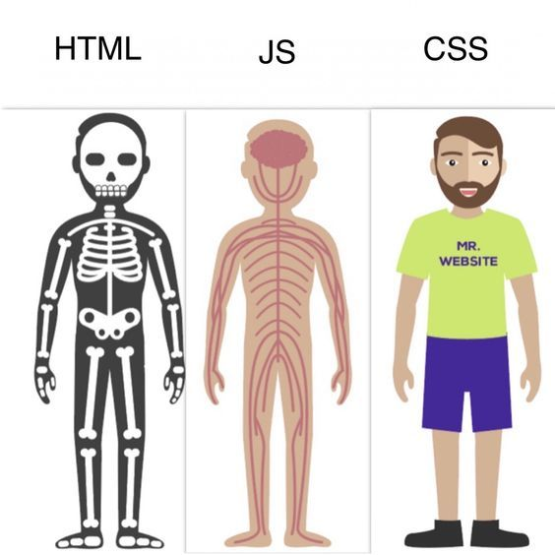

**1. HTML    **

Hypertext Markup Language (HTML) is the standard markup language for documents designed to be displayed in a web browser. It can be assisted by technologies such as Cascading Style Sheets (CSS) and scripting languages such as JavaScript. Web browsers receive HTML documents from a web server or from local storage and render the documents into multimedia web pages. HTML describes the structure of a web page semantically and originally included cues for the appearance of the document.

HTML elements are the building blocks of HTML pages. With HTML constructs images and other objects such as interactive forms may be embedded into the rendered page. HTML provides a means to create structured documents by denoting structural semantics for text such as headings, paragraphs, lists, links, quotes and other items. HTML elements are delineated by tags, written using angle brackets. Tags such as <img /> and <input /> directly introduce content into the page. Other tags such as <p> surround and provide information about document text and may include other tags as sub-elements. Browsers do not display the HTML tags, but use them to interpret the content of the page.

HTML can embed programs written in a scripting language such as JavaScript, which affects the behavior and content of web pages. Inclusion of CSS defines the look and layout of content. The World Wide Web Consortium (W3C), former maintainer of the HTML and current maintainer of the CSS standards, has encouraged the use of CSS over explicit presentational HTML since 1997.

**2. CSS    **

Cascading Style Sheets (CSS) is a style sheet language used for describing the presentation of a document written in a markup language like HTML.CSS is a cornerstone technology of the World Wide Web, alongside HTML and JavaScript.CSS is designed to enable the separation of presentation and content, including layout, colors, and fonts.This separation can improve content accessibility, provide more flexibility and control in the specification of presentation characteristics, enable multiple web pages to share formatting by specifying the relevant CSS in a separate .css file, and reduce complexity and repetition in the structural content.

CSS information can be provided from various sources. These sources can be the web browser, the user and the author. The information from the author can be further classified into inline, media type, importance, selector specificity, rule order, inheritance and property definition. CSS style information can be in a separate document or it can be embedded into an HTML document. Multiple style sheets can be imported. Different styles can be applied depending on the output device being used; for example, the screen version can be quite different from the printed version, so that authors can tailor the presentation appropriately for each medium.The style sheet with the highest priority controls the content display. Declarations not set in the highest priority source are passed on to a source of lower priority, such as the user agent style. The process is called cascading.

One of the goals of CSS is to allow users greater control over presentation. Someone who finds red italic headings difficult to read may apply a different style sheet. Depending on the browser and the web site, a user may choose from various style sheets provided by the designers, or may remove all added styles and view the site using the browser's default styling, or may override just the red italic heading style without altering other attributes.

**3. JavaScript    **

JavaScript s a high-level, interpreted scripting language that conforms to the ECMAScript specification. JavaScript has curly-bracket syntax, dynamic typing, prototype-based object-orientation, and first-class functions.Alongside HTML and CSS, JavaScript is one of the core technologies of the World Wide Web.JavaScript enables interactive web pages and is an essential part of web applications. The vast majority of websites use it,and major web browsers have a dedicated JavaScript engine to execute it.As a multi-paradigm language, JavaScript supports event-driven, functional, and imperative (including object-oriented and prototype-based) programming styles. It has APIs for working with text, arrays, dates, regular expressions, and the DOM, but the language itself does not include any I/O, such as networking, storage, or graphics facilities. It relies upon the host environment in which it is embedded to provide these features.

Initially only implemented client-side in web browsers, JavaScript engines are now embedded in many other types of host software, including server-side in web servers and databases, and in non-web programs such as word processors and PDF software, and in runtime environments that make JavaScript available for writing mobile and desktop applications, including desktop widgets.

The terms Vanilla JavaScript and Vanilla JS refer to JavaScript not extended by any frameworks or additional libraries. Scripts written in Vanilla JS are plain JavaScript code.Google's Chrome extensions, Opera's extensions, Apple's Safari 5 extensions, Apple's Dashboard Widgets, Microsoft's Gadgets, Yahoo! Widgets, Google Desktop Gadgets, and Serence Klipfolio are implemented using JavaScript.

**4. Bootstrap :**

The primary purpose of adding it to a web project is to apply Bootstrap's choices of color, size, font and layout to that project. As such, the primary factor is whether the developers in charge find those choices to their liking. Once added to a project, Bootstrap provides basic style definitions for all [HTML elements](https://en.wikipedia.org/wiki/HTML_element). The result is a uniform appearance for prose, tables and form elements across [web browsers](https://en.wikipedia.org/wiki/Web_browser). In addition, developers can take advantage of CSS classes defined in Bootstrap to further customize the appearance of their contents. For example, Bootstrap has provisioned for light- and dark-colored tables, page headings, more prominent pull quotes, and text with a highlight. In our project we have used bootstrap while creation of login and sign-up form.

**4.Project Design :**

For designing of Quiz-Time we used HTML, CSS, JavaScript. Following pages have been designed using HTML, CSS and JavaScript to handle the defined objective of this project.

1. Index :- This the first page which user observe after running the project.

This page is a welcome page .After press continue we will move to login page.

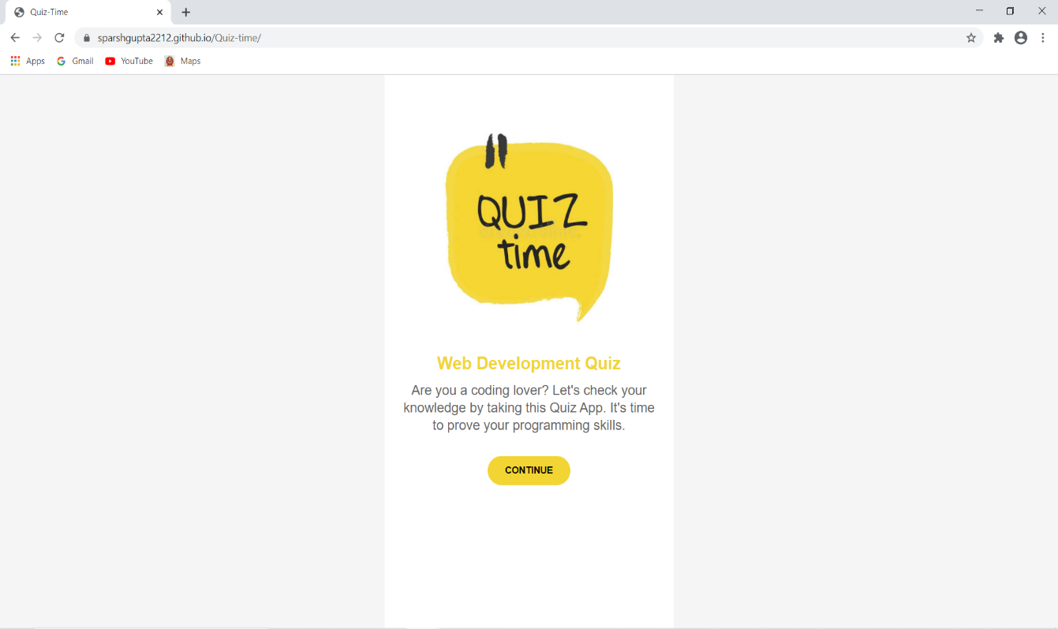

1. Login page:- This is our login page .

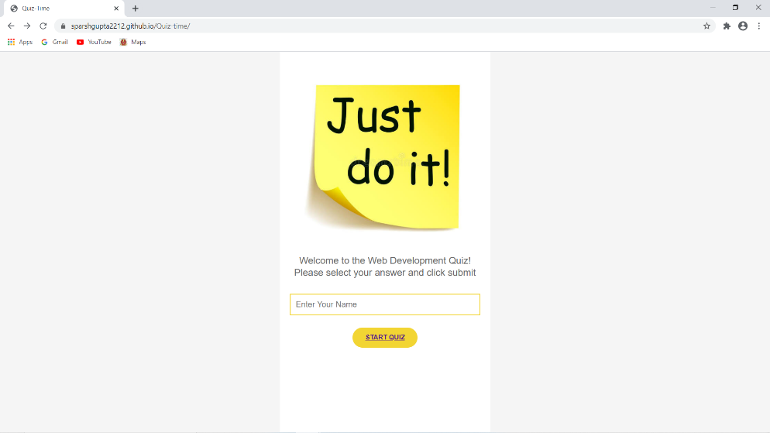

Alert Box :-If u don’t enter your name you get a alert message.

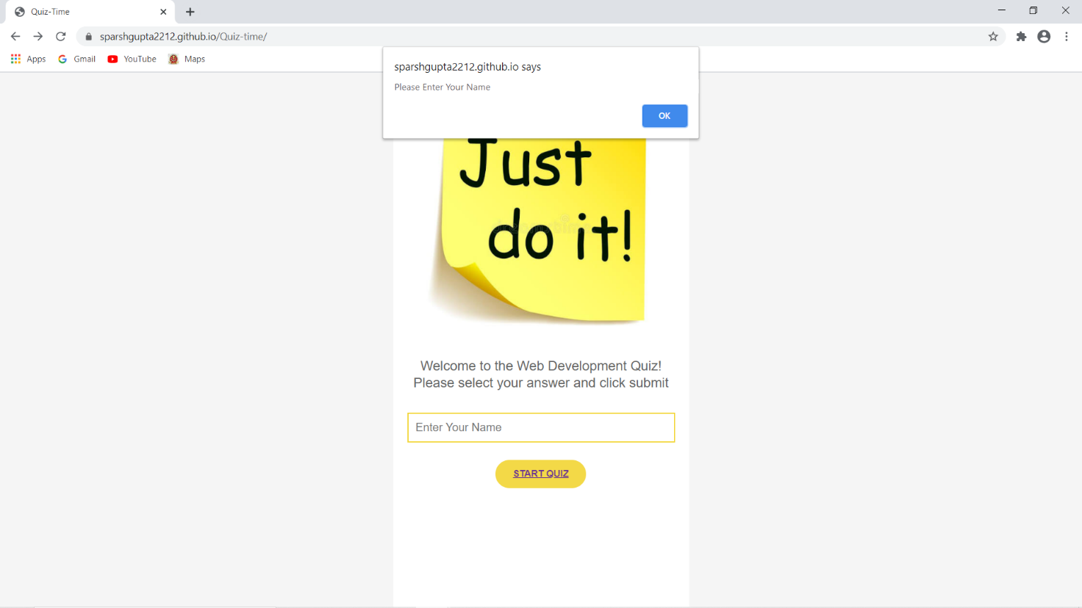

1. Attempt Quiz:- After login you will attempt select and test will look like.

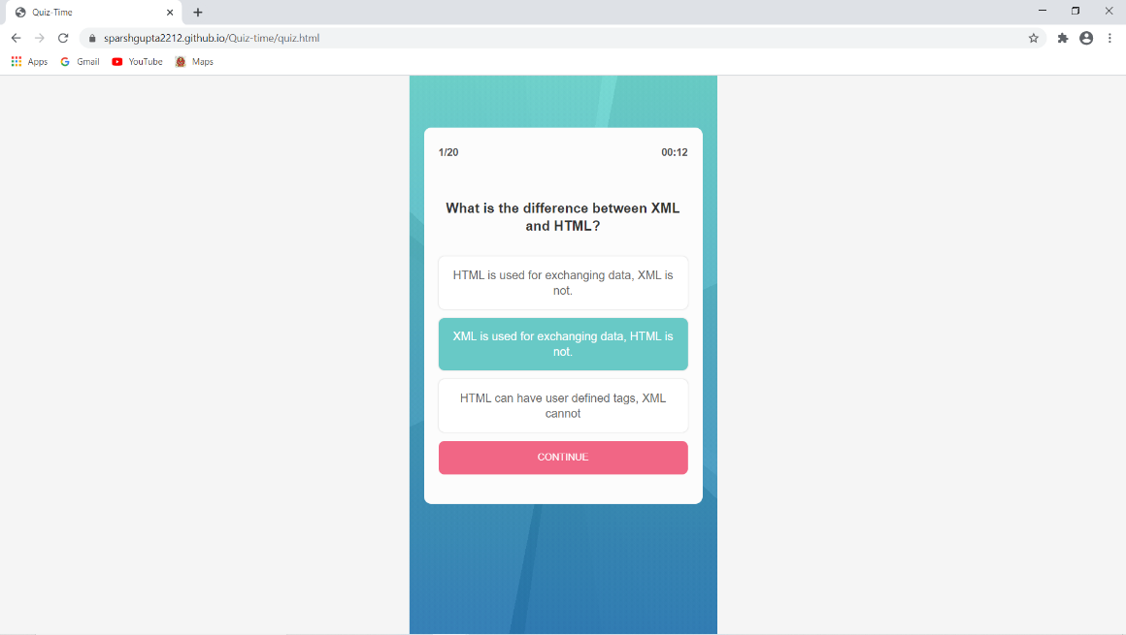

When your previous answer is correct/wrong you get information on next question.

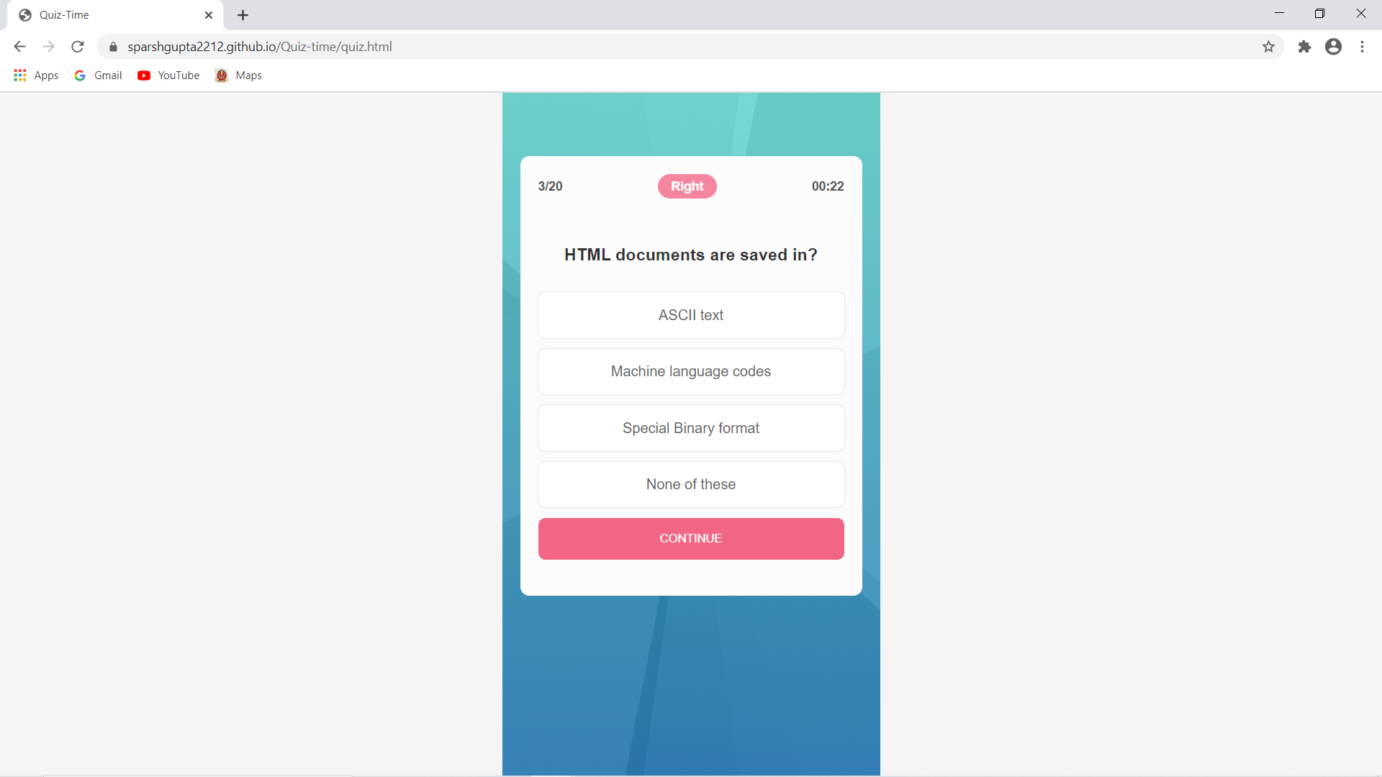

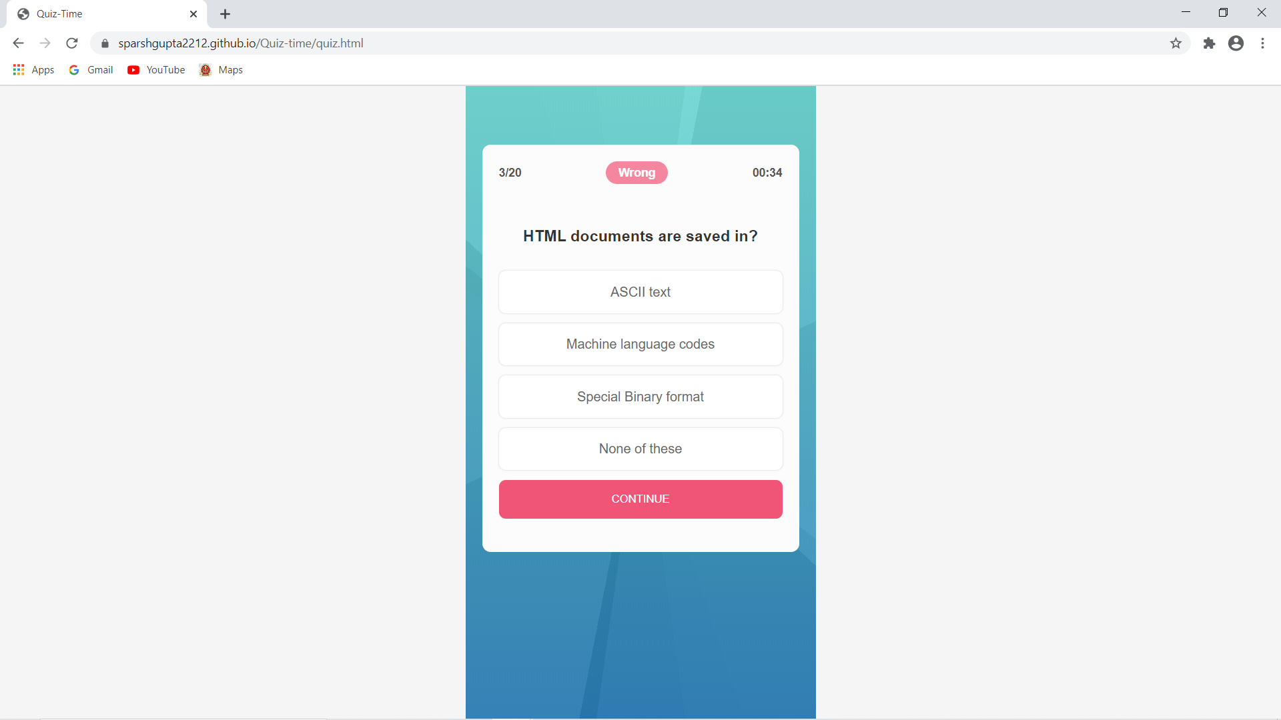

1. **End page:-**Click on check your answer we get a marks and answer.

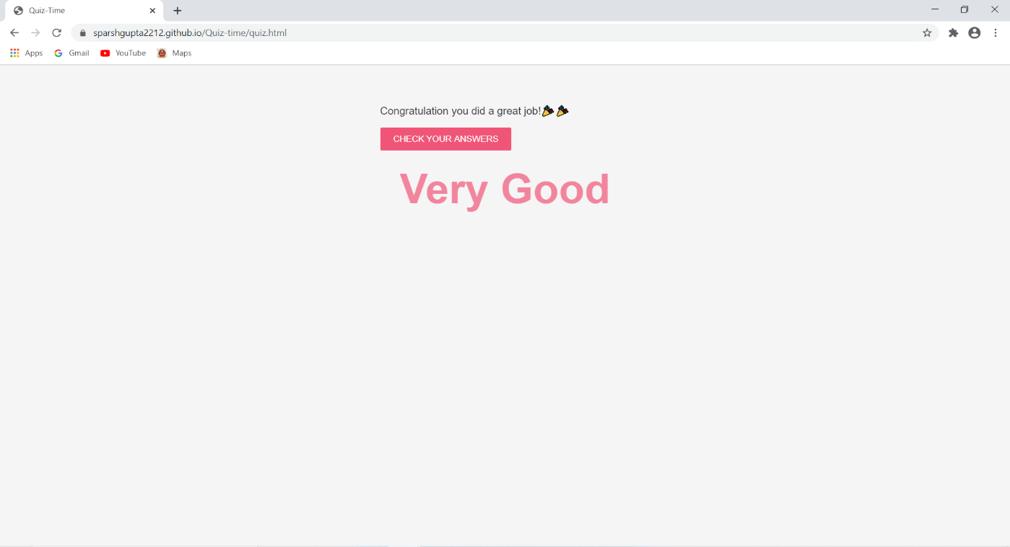

1. **Marks :-**

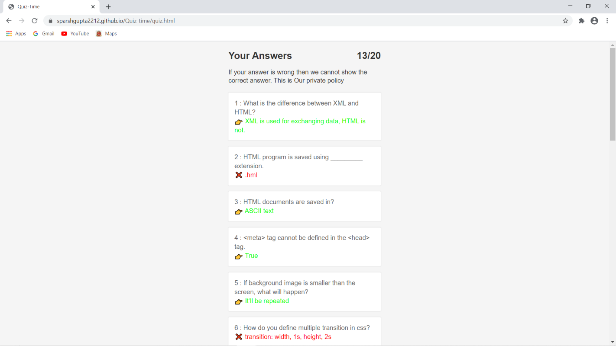

**5.Use case diagram:-**

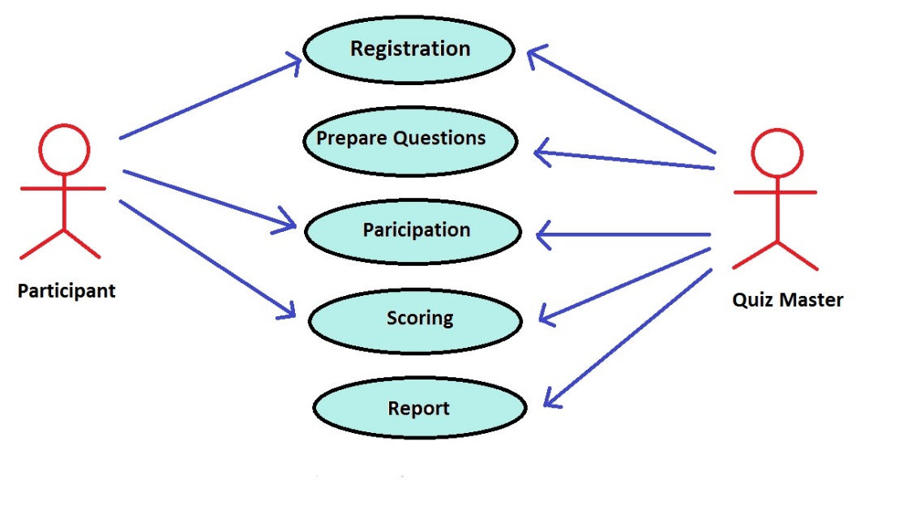

6.LIMITATIONS

**1. Cheating:** This website will allow user to change the page during the quiz and also due to objective questions only, cheating can be done easily.

**2. Weak Internet Connectivity:** Online examination system depends on the internet connection. Once as student starts a Quiz, it cannot be paused when allotted time runs out due to weak internet connection issue, quiz will no longer be accessible to student. Hence, high or average internet connection is required for a successful submission of quiz.

**3**. **Editing:** Once a student has taken a Quiz, you can no longer edit that quiz.

**4. Software:** If software/operating system fail student will not be able to give the exam and progress of examination data might be deleted if the system off abruptly.

**5. Server Crash:** This is also a serious problem at online platform.

**7.FUTURE SCOPE**

We are only done with the front end of the project while back-end is remaining.

In future i.e. in next semester we are supposed to complete the back- end of this website.

We are planning to keep managing the project and improving it based on user feedback. Here is our to do list for future

* We will add some more categories in our website.
* We’ll try to make it more user friendly than it is now.
* We’ll try to improve its quality.
* We’ll work on another feature in our app to add a module namely “Make Quiz” which is helpful for teachers to make their own quiz for their students.

**8. Advantages**

* It saves more time.
* It saves the student's money.
* It saves paper.
* It's more secure.

**9.CONCLUSION**

**Quiz-Time** is a quiz conducting global website. The main purpose of **Quiz-Time** is to offers new aspects of learning and improving knowledge in educational area. Most of the available apps are entertainment-based, which mostly do not contribute to the academic enhancement of the students. The theme of our project is to provide user to practice for objective tests conducted on national level, so in this website we focus on every field like humanities, science, maths , commerce etc. This quiz is useful for every user belongs to any field and for any type of online (non-pen paper) objective test.

The **Quiz-Time** is successfully designed and is tested for accuracy and quality. The key concept is to minimize the amount of paper work and convert all forms of documentation in digital form. The user with minimum knowledge of computer will also feel ease while using Quiz-Time. It will also provide an ease in retrieving information. It will also be a less time consuming platform for students and teachers as well. It will immediately produce your result and reflect it on your progress tracker.

Quiz System module will have information about quizzes that has been conducted at our website. Result module contains result of every user. Administrative module is completely under the admin, who will ensure you to secure your data from any kind of spam.

Thus, the proposed website can be easily adopted by universities and institutions in order to make the quiz based exam more secure and more flexible.

**10.REFERENCES :**

<https://www.beta-labs.in/>

<https://www.youtube.com/watch?v=yKaWJZBAXJk>

<https://codepen.io/missditch/pen/VmzKNv>

[www.google.com](http://www.google.com)